**Setting Up Your ITAD Server Recycling**

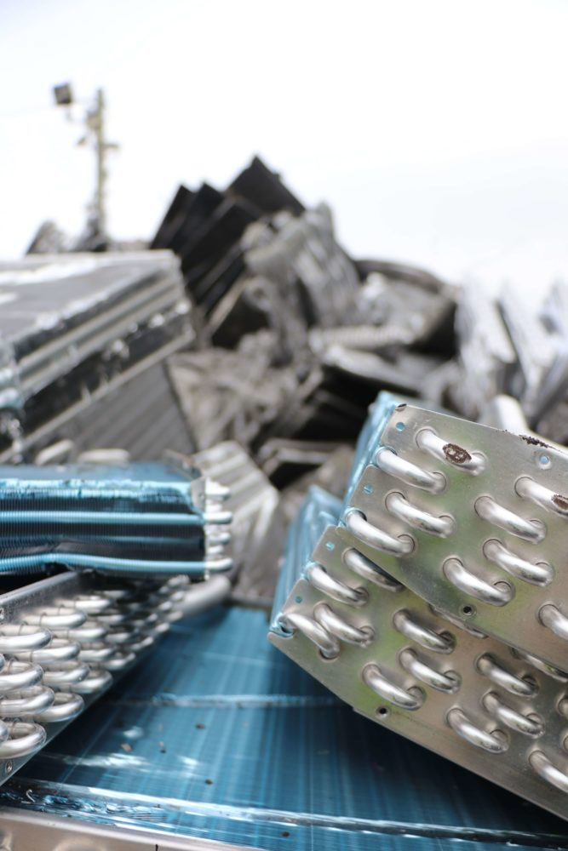

It is becoming increasingly important for businesses to try to reduce sensitive data leaks. One of your main goals should be to reduce your company's security vulnerabilities, and helping the environment can be a great side effect.

While there are numerous choices available to guarantee that you're establishing a safer, greener organisation, server recycling is an important service that you can use in your efforts to revamp your IT department.

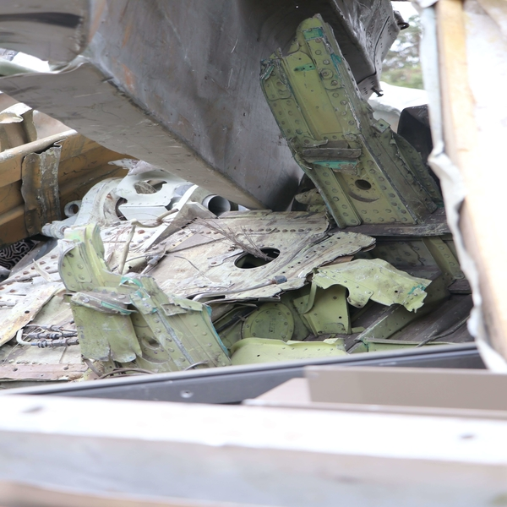

Many businesses have servers that are no longer in use or are in the process of being depreciated. Electronic garbage, however, constitutes a possible environmental danger, and its disposal must be done with care and intention.

**For eco-friendly disposal and asset management, server recycling is a good option.**

Some of the servers that your company could have are:

* A Mail Server
* Proxy Server
* Server Platforms
* Web Server
* Application Server
* Real-time Communication Server
* Ftp Server
* A Collaboration Server



Servers, like other types of electronic trash, contain hazardous chemicals in their components. Beryllium, cadmium, hexavalent chromium, lead, mercury, brominated flame retardant, and other toxic elements have been found in servers. Even less toxic metals like iron and copper can contaminate the groundwater near your local landfill.

Because improper disposal of this material is hazardous to the environment, legislation ensuring effective server recycling have been enacted.

**Developing or Revising Your IT Asset Disposition Procedure**

Your organisation is legally responsible for the correct disposal of your old servers, whether you do it yourself or engage a professional company. Keep in mind that you are in charge of all of your IT department's assets. As a result, you'll need to figure out how to recycle servers and other types of electronic garbage.

Any old, unused servers must be disposed as quickly as possible due to the risk of data breaches.

Hackers have the ability to breach firewalls and steal any data saved on the server. This puts your customers, staff, and vendors in jeopardy. If you have remote employees using your servers, this becomes much more of an issue, as there will be many different persons with access to secret information in many places.

**During disposal, your data security is most vulnerable.**

By simply discarding these obsolete servers, hackers get easy access to whatever information stored on them. Hard drives must be destroyed and recycled in order to eliminate any danger. Certificates of Destruction (CoD) obtained from a recycling business can also assist shield you from bogus legal claims.

**What is the Process of Server Recycling?**

The many components of a server are dismantled when it is recycled. Some companies merely dismantle useless equipment and sell the rest. Because recovered discs may be accessed and some data retrieved, this can be extremely risky.

Because not all electronic recyclers follow this technique, check with your commercial recycling supplier to ensure that any hardware that can hold data is totally destroyed.

**Three Major Steps:**

1. Collection and removal of waste
2. Recycling is where different components are removed and separated.
3. Data destruction and the shredding hard drives.

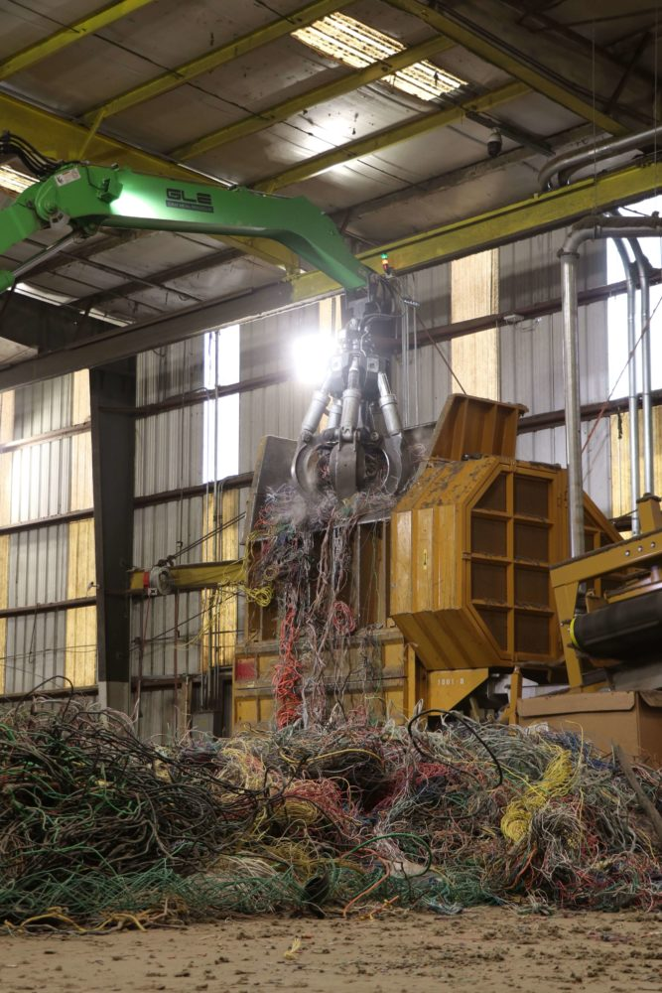

The bigger your company and the more servers you have, the longer IT asset management takes and the more likely you are to need an Asset Disposal contract.

**Contracts for server recycling**

You outsource your electronic waste recycling to a qualified disposal firm that knows how to properly recycle your old servers with a server recycling contract. You will have piece of mind knowing that your servers will be properly protected and kept safe from hackers, as well as disposed of in a healthy and environmentally friendly manner, if you hire a professional.

Professional server recyclers will erase the storage and memory of your servers, as well as recycle all components. You won't have to worry about safeguarding your servers after they've been retired if you use this service.

**Choosing the Best Recycling Company**

Hire a [waste removal business](https://www.recyclepro.co.uk/) that is familiar with all EPA regulations, has a lot of expertise, and you can trust to perform the job correctly. Your prices should be all-inclusive with a contract, covering all three aspects of server recycling.

You'll also be aware that all you have to do if you have obsolete servers that need to be recycled is contact your waste disposal provider. Your company employs servers and will occasionally require server recycling services. Hiring a disposal provider to satisfy these requirements will give you piece of mind while also protecting your data and the environment.